RAINMATTER : Urban
Concept Note
The Operating Logic of a Place: From Ownership to Interoperability

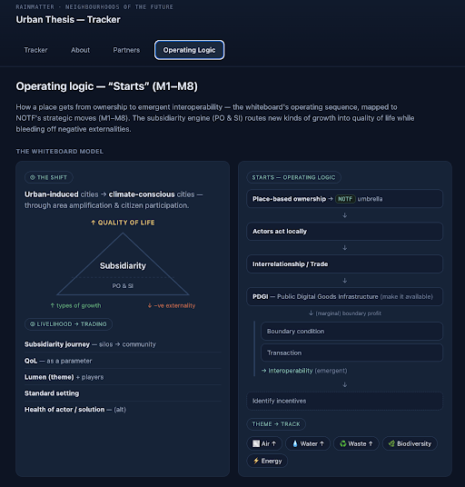

Purpose. This note explains the operating sequence behind the Neighbourhoods of the Future (NOTF) model. It describes how a place moves from being simply owned to becoming interoperable, so that new kinds of green growth can be turned into a better quality of life while we reduce negative externalities.
The Shift We Are Working Towards
The core idea is a move from climate induced cities to climate conscious cities. Cities today grow by adding layers of scale on top of scale. We want that growth to be shaped instead, by awareness of climate and by the active participation of citizens. When this happens, the quality of life in a place rises even as the pressure it places on the environment falls.
Subsidiarity as the Engine
At the centre of the model sits the principle of subsidiarity, supported by two forces we describe as Public Ownership and Shared Infrastructure. Subsidiarity means that decisions and action stay as close to the local level as possible. This engine does useful work in two directions at once. It lifts up the positive green growth a place can create, and it reduces the negative externalities.
The journey we want each place to take runs from silos to community. Instead of separate actors working in isolation, the aim is a connected community where trade-offs and interoperability become normal. Along the way, quality of life is not treated as a vague outcome but as a set of parameters, something we can set standards for and measure. The health of every actor and every solution is checked as an alternative to measuring success by scale alone.
How a Place Starts: The Operating Sequence
The principles set out the practical steps, moving from ownership towards interoperability. Each step builds on the one before it.
- Place based ownership: A place begins with clear local ownership, held under a shared umbrella such as NOTF.
- Local action: Ownership only matters when actors act locally, taking decisions and responsibility on the ground.
- Intersectionality: Local actors then move into interoperability and trade, exchanging value with one another rather than staying separate.
- Open and shared digital goods: This trade is supported by making Public Digital Goods Infrastructure (PDGI) available to everyone, which lowers the cost of cooperating and unlocks value at the margins.
- Interoperability: Within this infrastructure, clear boundary conditions and transactions allow interoperability to emerge naturally as a property of the whole system.
- Incentives: Finally, the model helps a place identify incentives, so that the right behaviour is rewarded and sustained over time.
From Theme to Track
The final stage connects the operating logic to the things a place actually cares about. Broad themes are turned into concrete tracks that can be tracked and improved, including air, water, waste, biodiversity, and energy. Each track becomes a practical area where a neighbourhood can measure progress and take action.
In Short
The model reads as a single arc. A place that starts with local ownership, acts locally, surfaces trade-offs, and shares digital infrastructure gradually becomes interoperable. Guided by subsidiarity, this interoperability raises quality of life while reducing environmental harm, and it does so across the tracks that matter most to people who live there.
Theme
Air : Artefact: oaq.notf.in
A multi-stakeholder open and public platform that allows for India to learn about Air and Air quality. Organisations part of this endeavour - CSTEP, Aurassure, BPAC, Tarkam, HNI’s, Oorvani, Socratus, UnBoxingBlr, WRI etc.
Water : Health and Quality
We at the foundation are supporting organisations across different water systems such as groundwater, rivers, lakes, back waters working on water availability and health of the water. This includes areas of intervention with the other domains around them that contribute to the health and quality like waste, industries, ecology of these systems. Paani Foundation, Biome, Eco-Sattva, Tags Forum, WRI are a few to name. Ongoing conversations with Paani.earth.
Waste : Material Recycling Facility (MRF)
We at the foundation are exploring areas of intervention to strengthen the upstream and downstream ecosystem that enables strengthening of the MRF. This will bring together the market, government, and non-profits to complete the value chain. Some organisations we are engaged with are WRI, Saahas, Socartus etc and our Rainmatter Capital team, through their investees, who also add value and help complete the lifecycle of waste within and for the sector.
Energy : Generate where you consume.
We at the foundation are exploring strengthening the programs and addressing challenges with Rooftop and Agri systems through solar, alternate sustainable sources of energy keeping in mind, demand side of things, adoption of programs like PM Suryaghar and PM Kusum. Orgs like WRI, CSTEP, CEEW, SFC are a few we have supported in the process.
Urban Biodiversity and Built environment:
We at the foundation are driving the enablement of concepts of co-existence, enabling better relationships between parks, people, lakes, and the built environment. Some organisations in this space are, Farmers 4 Forest, Ethos foundation, Nirmaan institute, Saytrees, ATREE, Arocha to name a few.
Where the Tracks Intersect
The tracks are not five parallel programmes; they are one system whose parts trade with each other. This is where interoperability stops being a principle and becomes visible: each track’s negative externality is another track’s input. Where a silo would simply dump a cost, a connected community routes it as value.
- Water × Waste: The effluents and leachate of industry and solid waste seep into the groundwater and disturb the health of the water system, which in turn shows up as poor water quality downstream.
- Waste × Air × Health: Legacy landfill and dump sites release methane and carbon monoxide as they degrade — feeding air pollution and further health implications.
- Energy × Waste × Agri: Biogas and other alternate sources recovered from waste help power AgroPV, letting a place generate where it consumes and address demand-side pressure at the same time.
- Waste (MRF) × Circular economy: Strengthening the Material Recovery Facility plugs into the legacy-waste system; Rainmatter Capital investees complete the value chains of the circular economy — PET plastics, textiles, and electronic waste.
- Built environment × Energy × Carbon: The built environment works on operational carbon in daily use, while embodied carbon is offset through the strengthening of rooftop (RTPV) and agri (AgroPV) solar systems.
Read together, these intersections are the interoperability the operating sequence is designed to produce: externalities become inputs, trade-offs become transactions, and every loop resolves toward the one shared outcome — a better quality of life.
Prepared for the Neighbourhoods of the Future initiative, Rainmatter Foundation.

